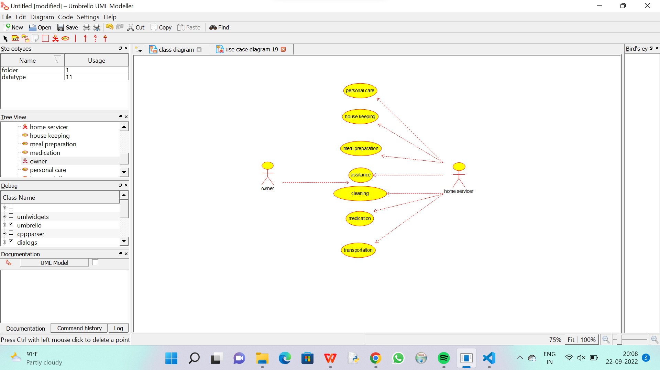

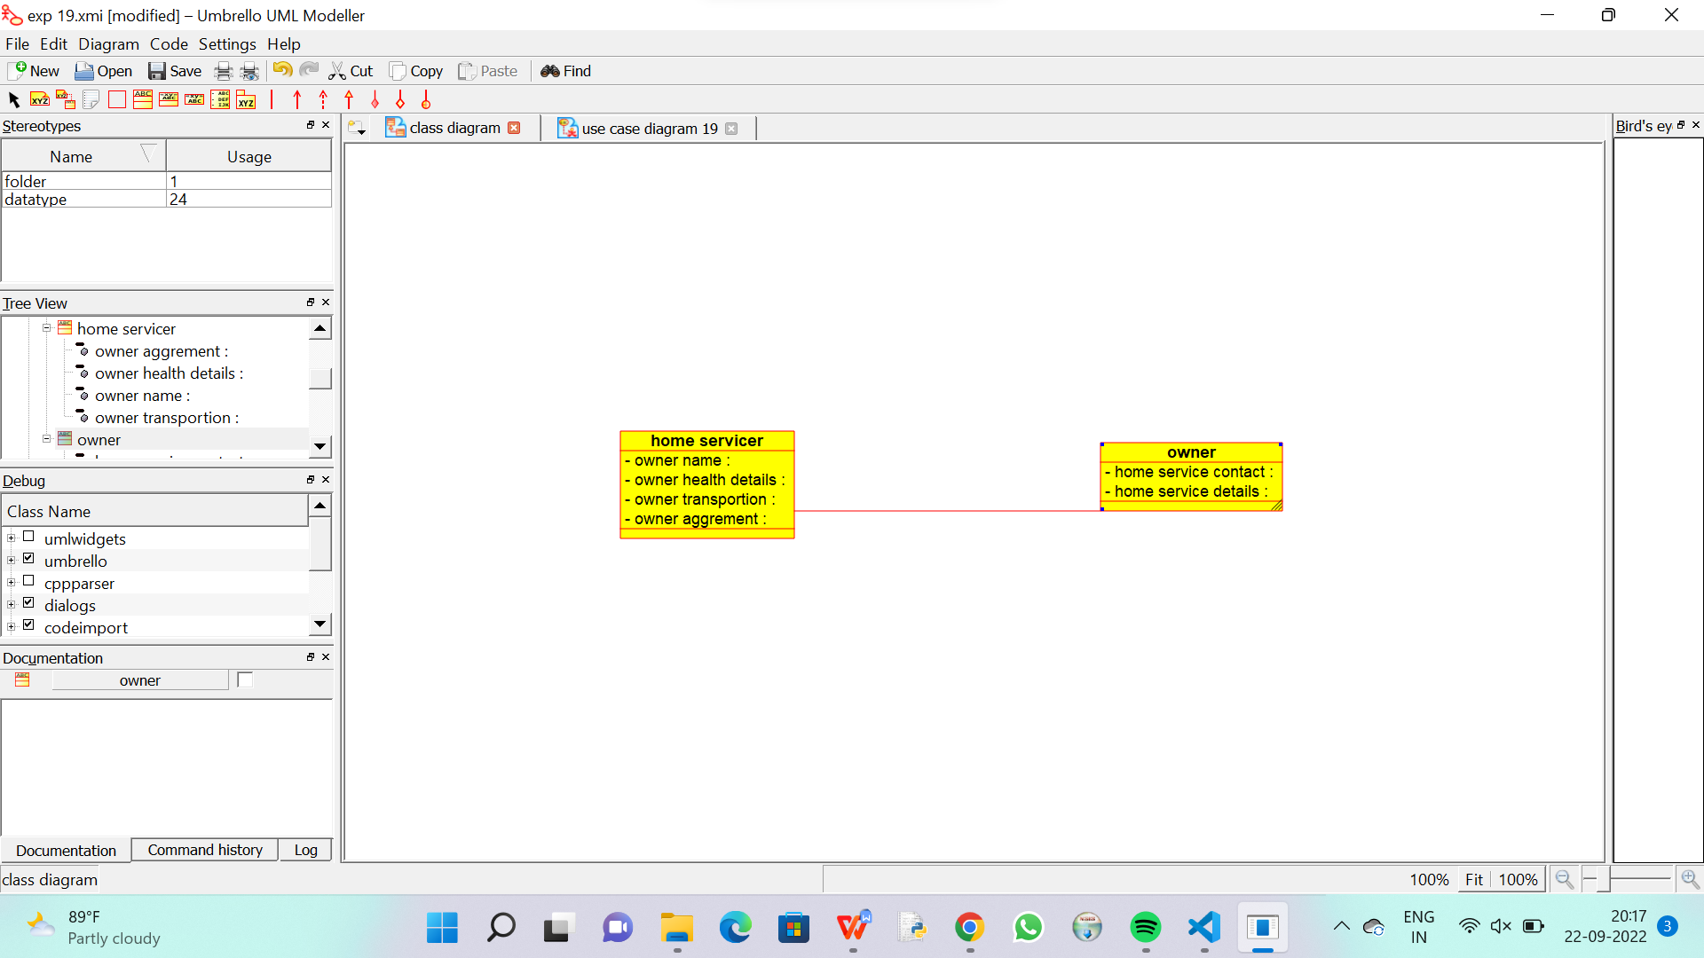

CODE FOR HOME SERVICER :

import java.util.*;

/**

 * Class home_servicer

 */

public class home_servicer {

  //

  // Fields

  //

  private void owner_name;

  private void owner_health_details;

  private void owner_transportion;

  private void owner_aggrement;

  //

  // Constructors

  //

  public home_servicer () { };

  //

  // Methods

  //

  //

  // Accessor methods

  //

  /**

   * Set the value of owner_name

   * @param newVar the new value of owner_name

   */

  private void setOwner_name (void newVar) {

    owner_name = newVar;

  }

  /**

   * Get the value of owner_name

   * @return the value of owner_name

   */

  private void getOwner_name () {

    return owner_name;

  }

  /**

   * Set the value of owner_health_details

   * @param newVar the new value of owner_health_details

   */

  private void setOwner_health_details (void newVar) {

    owner_health_details = newVar;

  }

  /**

   * Get the value of owner_health_details

   * @return the value of owner_health_details

   */

  private void getOwner_health_details () {

    return owner_health_details;

  }

  /**

   * Set the value of owner_transportion

   * @param newVar the new value of owner_transportion

   */

  private void setOwner_transportion (void newVar) {

    owner_transportion = newVar;

  }

  /**

   * Get the value of owner_transportion

   * @return the value of owner_transportion

   */

  private void getOwner_transportion () {

    return owner_transportion;

  }

  /**

   * Set the value of owner_aggrement

   * @param newVar the new value of owner_aggrement

   */

  private void setOwner_aggrement (void newVar) {

    owner_aggrement = newVar;

  }

  /**

   * Get the value of owner_aggrement

   * @return the value of owner_aggrement

   */

  private void getOwner_aggrement () {

    return owner_aggrement;

  }

  //

  // Other methods

  //

}

CODE FOR OWNER :

import java.util.*;

/**

 * Class owner

 */

public class owner {

  //

  // Fields

  //

  private void home_service_contact;

  private void home_service_details;

  //

  // Constructors

  //

  public owner () { };

  //

  // Methods

  //

  //

  // Accessor methods

  //

  /**

   * Set the value of home_service_contact

   * @param newVar the new value of home_service_contact

   */

  private void setHome_service_contact (void newVar) {

    home_service_contact = newVar;

  }

  /**

   * Get the value of home_service_contact

   * @return the value of home_service_contact

   */

  private void getHome_service_contact () {

    return home_service_contact;

  }

  /**

   * Set the value of home_service_details

   * @param newVar the new value of home_service_details

   */

  private void setHome_service_details (void newVar) {

    home_service_details = newVar;

  }

  /**

   * Get the value of home_service_details

   * @return the value of home_service_details

   */

  private void getHome_service_details () {

    return home_service_details;

  }

  //

  // Other methods

  //

}